Assignment 4

One-way functions and complexity theory, part 1

The Basics
Before class on Wednesday 9/24: read this document and make note of any questions you might have.

Wednesday 9/24 and Friday 9/26: will be studio classes devoted to this assignment.

Monday 9/29: present your assignments

Monday 10/6: final version due in class.

Cryptography is the problem of encoding (“encrypting”) a message from a sender (usually called “Alice”) to a receiver (“Bob”) without an evesdropper (“Eve”) being able to decode (“decrypt”) the message. Fundamental to cryptography is the notion of a one-way function, which loosely speaking is a function that is easy to compute but hard to invert. If f is a one-way function, then we can use it to encrypt a message from Alice to Bob, since there is no function Eve can use to invert it.
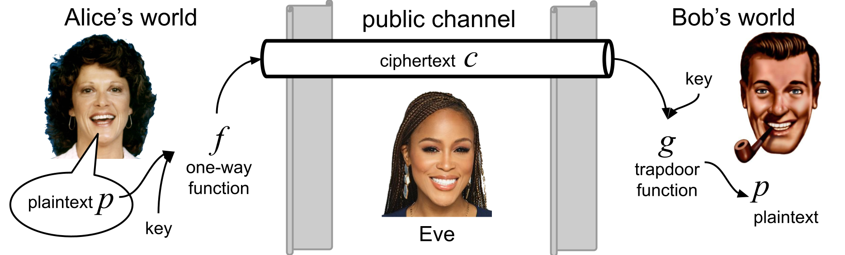

Certainly, a one-way function is not all that is needed for a cryptographic system. For it to be useful, Bob must also be able to decrypt Alice’s message. But we’re getting ahead of ourselves because, even though cryptographic systems exist, we still have not confirmed the existence of a single one-way function! Not one. The security of all known cryptographic systems is based on encryption functions for which no inversion functions are (yet) publicly known to exist. But this does not preclude them being suddenly discovered in the future or (improbably) from already having been discovered by some malicious agent or organization but kept secret.

However, there are strong connections between one-way functions and other open problems, such as whether P = NP. In fact, it is fairly easy to show that if one-way functions exist, then P ≠ NP. How? Let’s try to write a proof.

First, we need a formal definition of a one-way function. As in many things theoretical, several different definitions exist. For this assignment we will use the following

Definition 1: A function f is called one-way if there exists a polynomial q and a deterministic Turing machine F computing f such that, on all inputs x,
- F(x) runs in fewer than q(|x|) steps (i.e., F runs in polynomial time)
- q(|f(x)|) > |x|
- f⁻¹ is not computable in deterministic polynomial time.

Theorem 2: If one-way functions exist, then P ≠ NP.

Proof idea. Suppose that one-way functions exist. Then let f be a one-way function that has all the properties of Definition 1. Now, consider the following (formal) language.

L = { 〈w, y〉 | f ⁻¹(y) < w }

Here 〈·, ·〉is called a pairing function. It takes two binary strings w and y and outputs a single binary string via a 1-1, invertible mapping, polynomial-time computable function. Describe how such a function might work in a way that is plausible for it to run in polynomial time in the length of its longest input.

On input〈w, y〉[Describe a new string x in terms of w and y]

Output x.

Now describe the inverse function 〈·〉 ⁻¹

On input〈x〉[Describe a new strings in terms of w and y]

Output w and y.

